IP Addressing and Subnetting Assignment

- Key Differences Between IPv4 and IPv6 Addressing

IPv4 | IPv6
Uses 32-bit addresses. | Uses 128-bit addresses.
Written in decimal, e.g. 192.168.1.1. | Written in hexadecimal, e.g. 2001:db8::1.
Provides about 4.3 billion addresses. | Provides an extremely large address space.
Supports broadcast communication. | Does not use broadcast; uses multicast/anycast.
NAT is commonly used. | NAT is generally not required for address conservation.
Manual configuration or DHCP can be used. | Supports SLAAC, DHCPv6, and manual configuration.

- Static IPv4 Address Assignment for Home WiFi Devices

Network: 192.168.10.0/24
Subnet Mask: 255.255.255.0
Default Gateway: 192.168.10.1
Device | IP Address | Subnet Mask | Default Gateway
Laptop | 192.168.10.10 | 255.255.255.0 | 192.168.10.1
Phone | 192.168.10.20 | 255.255.255.0 | 192.168.10.1
Smart TV | 192.168.10.30 | 255.255.255.0 | 192.168.10.1
Printer | 192.168.10.40 | 255.255.255.0 | 192.168.10.1

- /27 Subnetting on the 192.168.1.0 Network

CIDR: /27 = Subnet Mask 255.255.255.224
Borrowed subnet bits from a /24 network: 27 - 24 = 3
Number of subnets: 2³ = 8
Addresses per subnet: 2⁵ = 32
Usable hosts per subnet: 32 - 2 = 30
Block size: 256 - 224 = 32
Subnet | Network Address | Usable Host IPs | Broadcast Address
1 | 192.168.1.0 | 192.168.1.1 - 192.168.1.30 | 192.168.1.31
2 | 192.168.1.32 | 192.168.1.33 - 192.168.1.62 | 192.168.1.63
3 | 192.168.1.64 | 192.168.1.65 - 192.168.1.94 | 192.168.1.95

- Network Details for 10.0.5.17 / 255.255.255.0

IP Address: 10.0.5.17
Subnet Mask: 255.255.255.0
CIDR Notation: /24
Network Address: 10.0.5.0
Broadcast Address: 10.0.5.255
Valid Host Range: 10.0.5.1 - 10.0.5.254
Calculation: 255.255.255.0 is /24. Applying the mask to 10.0.5.17 gives network 10.0.5.0. The last address in the /24 subnet is 10.0.5.255, so usable hosts are 10.0.5.1 through 10.0.5.254.

- Verification Using an Online Subnet Calculator

The values were verified using an online subnet calculator with IP address 10.0.5.17 and subnet mask 255.255.255.0 (/24).
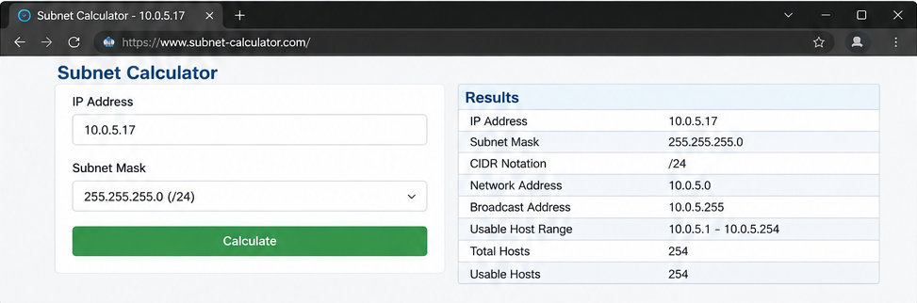
Result: My manual answer matched the subnet calculator output: network address 10.0.5.0, broadcast address 10.0.5.255, and usable host range 10.0.5.1 - 10.0.5.254.

